TPC Scottsdale’s final holes encourage Open drama, tight finishes
William Neary Special for The Republic
Feb. 7, 2026, 6:09 p.m. MT

Boisterous fans. Beer showers. Joel Dahmen and Harry Higgs shirtless on the 16th green in 2022. Of all the things that distinguish the WM Phoenix Open from other tournaments on the PGA Tour, Scottie Scheffler has one to add.

The closing stretch.

“I think this golf course is one of the best ones we see all year in terms of an exciting finish,” said Scheffler, two-time winner of the WM Open and current World No. 1. “There is opportunity, but a lot of danger.”

TPC Scottsdale’s finishing holes encourage drama. With par 5s on holes 13 and 15, the stadium 16th par 3, the driveable par-4 17th hole, and the treacherous 18th, almost no lead is secure.

Scheffler knows the WM Open’s host course, TPC Scottsdale, as well as anyone. It’s where he secured his maiden PGA Tour victory in 2022, and where he defended that title in 2023.

In those years, he played the final six holes on Sunday in 4-under-par and 3-under-par, respectively. When he didn’t win, he was never able to surpass 1-under-par over that stretch.

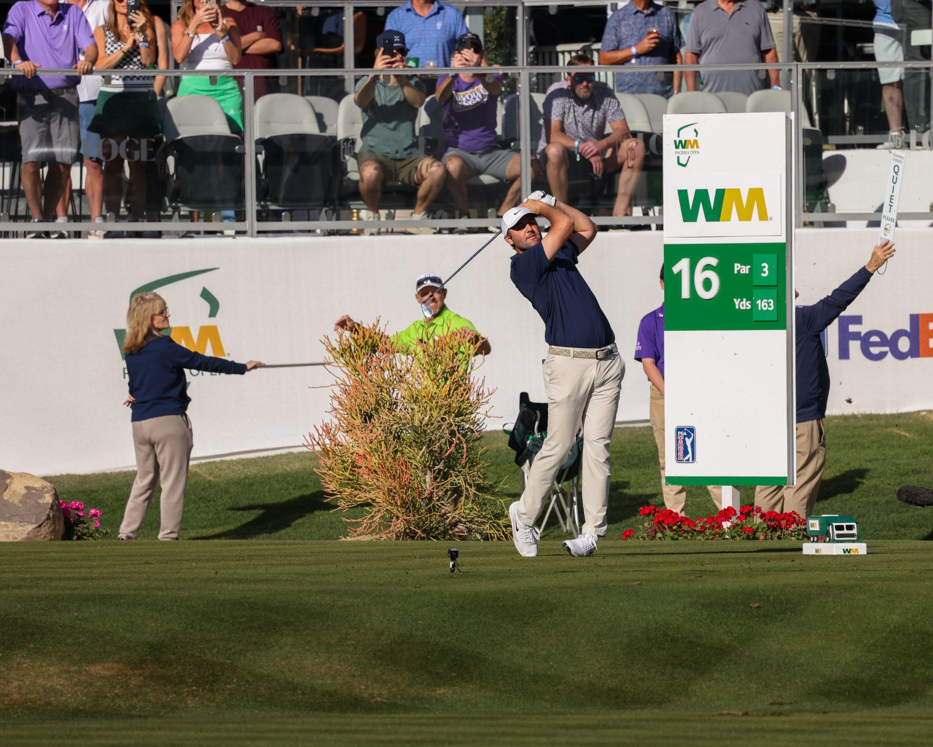
Scottie Scheffler tees off on the famous 16th hole at the WM Phoenix Open Thursday. Alex Strizek/Special to The Republic

Each hole presents its own unique balance of risk and opportunity. The 15th hole, a challenging par-5 with water left and an island green, is perhaps the best example.

“You look at the second shot on 15,” Scheffler said. “If you hit a really good shot there you can get a really good look for eagle, but if you hit a poor shot you’re going to be in the water staring bogey in the face.”

In four trips down the 15th hole in 2025, Scheffler went for the green on three occasions. The gamble paid off in the first round, as his 244-yard approach settled around 8 feet from the hole. The putt dropped for an eagle.

The final two rounds brought different results. Scheffler, on the edge of contention as he stood in the rough right of the 15th fairway, chose to go for the green. His shot drew left of the green and found water. He made bogey.

He’d find the water once again with his second shot the next day.

Others choose to air on the side of caution, rarely targeting the green with their second shot. Nick Taylor, champion of the 2024 WM Phoenix Open and runner-up in 2023, is one.

“If I’ve had 4-iron or less (into the green) I’ve laid up every time,” Taylor said.

He emphasized that this safer approach decreased the likelihood of scoring over par on the 15th hole while still allowing him an opportunity for a birdie with a wedge for his third shot.

But even this caution may not be rewarded.

“If you pull that second shot off (on the par-5 15th) you’ll have an eagle look,” said Sahith Theegala, now in his fifth full year on the PGA Tour. “But if not you would almost take a five. It’s such a hard wedge shot into those greens.”

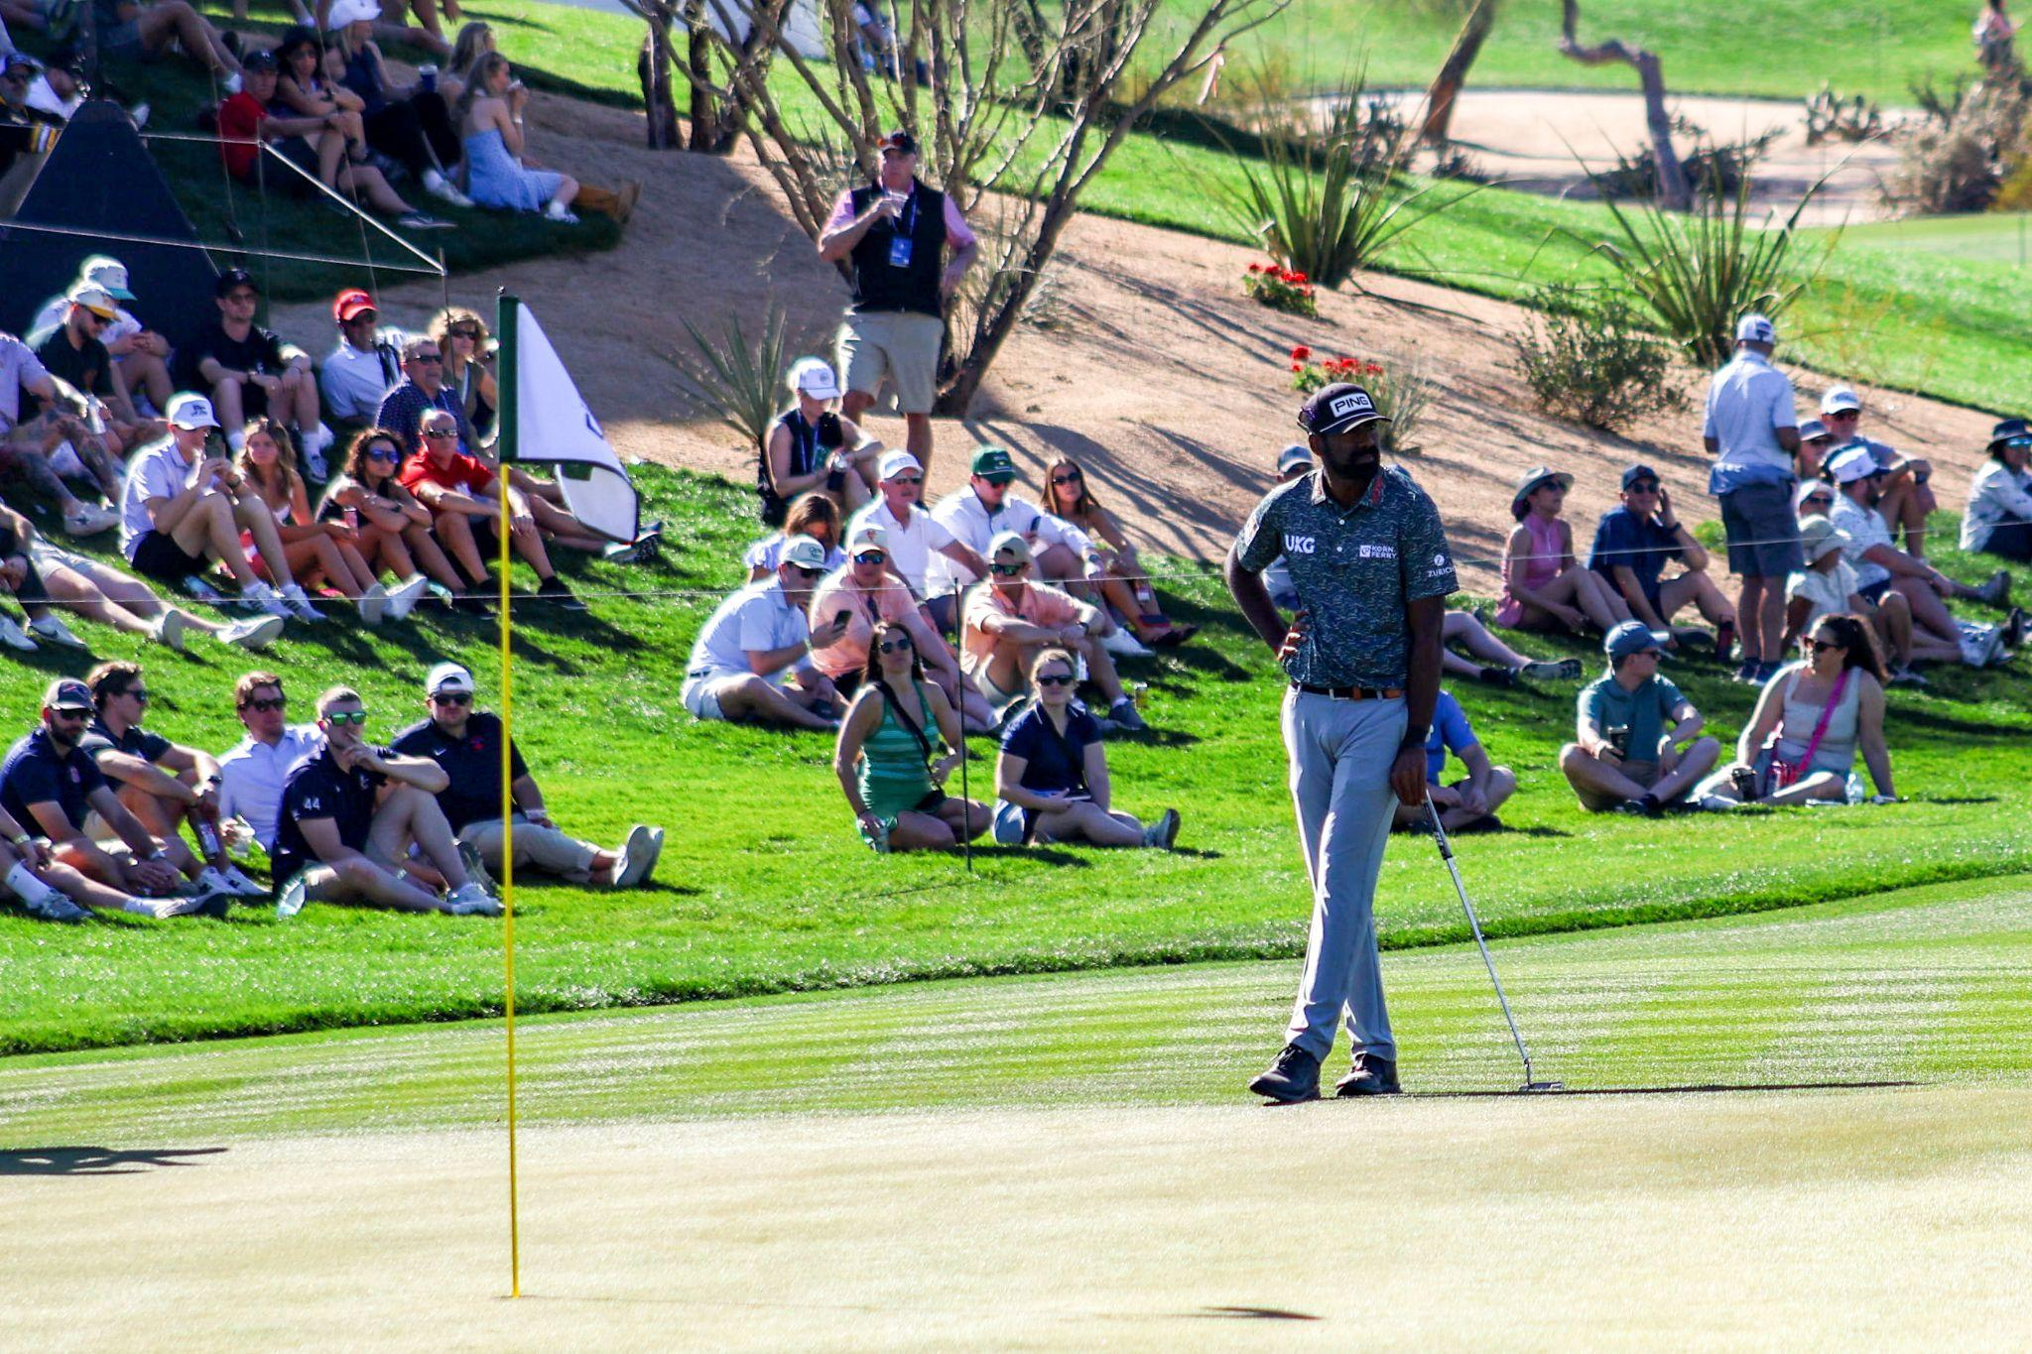
Sahith Theegala waits near the 6th green during Friday’s round at the WM Phoenix Open. Annika Morris/Special to The Republic

The threat of water is not unique to the par-5 15th hole. It looms long and left of the green on the driveable-par-4 17th, and sits between the tee box and the fairway on hole 18.

These final two holes proved consequential for Theegala in 2022. Tied for the lead as he stood on the 17th tee, he opted to stay aggressive. His tee-ball, a 2-hybrid, kicked left, rolled over the left side of the green and found water.

He would finish one shot outside a playoff with a costly bogey on 17. Four years later he says he still finds himself thinking back to that one swing more often than he’d like.

The 16th hole, perhaps one of the most famous in golf, might not be as architecturally difficult as some others. But what it lacks in length and treachery it makes up for in atmosphere.

“If you just hit a poor shot (on the 16th hole) or get overwhelmed you can make a four there pretty easily,” Taylor said.

Staying calm in that coliseum is no small feat. The fans, famously rambunctious and often a few drinks in, won’t hesitate to boo a shot that sails wide of the green or settles in a bunker. But should a tee-shot find the bottom of the hole, showers of beer rain onto the players and the green.

On the par-3 16th and the holes that surround it the players are forced into decision. Be bold and risk disaster, or air towards safety and open the door for others? It’s a question that the Phoenix Open asks perhaps better than any other course down its final holes.

“I think it’s a fantastic finish that provides a great amount of opportunity,” Scheffler said, “but there can also be pretty severe penalties as well.”

As the final, leading groups work their way through this stretch under fading light on Sunday afternoon, this debate between aggression and caution will be on full display.

The WM Phoenix Open, more so than most tournaments on the PGA Tour, is not over until the final putt drops.

Will Neary is a graduate student at Northwestern’s Medill School of Journalism

